Changes I Am Making To Keep Healthy
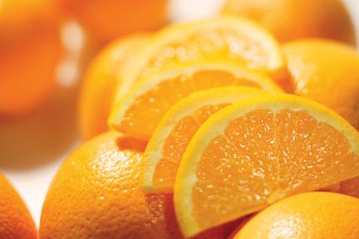
Write in your goals by the numbers below.
Give yourself a star every day you accomplish your goal!

Goals | M | T | W | Th | F | Sa | Su
1.

Week 1
Week 2
Week 3
Week 4
2.

Week 1
Week 2
Week 3
Week 4
3.

Week 1
Week 2
Week 3
Week 4

Reward: ____________________________________

___Eat 5-9 servings of fruits and vegetables each day (1 serving= ½ cup)
___Limit juice, soda and sugared drinks -- instead, drink water between meals!
___Change milk to 1% or 2%
___Eat breakfast every day
___Eat at home! Decrease fast food, restaurant, and cafeteria food to ___ per week
___Offer less food at each meal (use smaller plates and cups)
___Offer lower fat foods at each meal, and cook with less fat
___Eat as a family at least 5 times each week (TV off!)
___No more than 1- 2 hours of TV, computer or video games per day
___Play or exercise (walking) 60 minutes each day

